Supplementary Material
High Sensitivity Troponin T and NT-proBNP in Patients Receiving Chimeric Antigen Receptor (CAR) T-Cell Therapy
Jiun-Ruey Hu, MD, MPH^{1,2}, Ameet Patel, MD³, Shi Huang, PhD¹, Yan Ru Su, MD¹, Kimberly B. Dahlman, PhD³, Kelsey Tomasek, BS¹, Yueli Zhang, BS¹, Richard T. O’Neil, PhD⁴, Jamye F. O’Neal, BS⁵, Isik Turker, MD¹, Douglas B. Johnson, MD, MSCI³, Joe-Elie Salem, MD, PhD^{6,7}, Javid J. Moslehi, MD^{1,7}, Olalekan Oluwole, MBBS, MPH³
- Division of Cardiovascular Medicine, Vanderbilt University Medical Center, Nashville, TN
- Division of Cardiovascular Medicine, Yale School of Medicine, New Haven, CT
- Division of Hematology/Oncology, Vanderbilt University Medical Center, Nashville, TN
- Division of Nephrology and Hypertension, Vanderbilt University Medical Center, Nashville, TN
- Vanderbilt Ingram Cancer Center, Vanderbilt University Medical Center, Nashville, TN
- Department of Pharmacology, AP-HP, Pitié-Salpêtrière Hospital, Paris, France
- Cardio-Oncology Program, Vanderbilt University Medical Center, Nashville, TN

Supplementary Tables:
- Table S1: Pairwise Wilcoxon comparisons for (Top) hsTropT and timepoints and (Bottom) hsTropT and timepoints, with subgroups for CRS and baseline lab values
- Table S2: (Top) hsTropT levels and (Bottom) NTproBNP levels at each timepoint, with subgroups for presence of cardiac comorbidities
- Table S3: (Top) hsTropT levels and (Bottom) NTproBNP levels at each timepoint, with subgroups for presence of ICANS

Supplementary Figures:
- Figure S1: Correlation between baseline serum hsTropT and baseline serum creatinine
- Figure S2: Dot plots for serum hsTropT and NTproBNP with respect to timepoint, with subgroups for CRS and baseline hsTropT
- Figure S3: Swimmer plots for serum hsTropT and NTproBNP with respect to timepoint, with subgroups for CRS and baseline hsTropT
- Figure S4: Box plots for serum hsTropT and NTproBNP with respect to timepoint, with subgroups for cardiac comorbidities
- Figure S5: Box plots for serum hsTropT and NTproBNP with respect to timepoint, with subgroups for ICANS
Table S1: (Top) Pairwise Wilcoxon signed rank exact tests illustrating specific pairs of timepoints where levels hsTropT levels were significantly different, for the full group, subgroups by cytokine release syndrome (CRS), and subgroups by abnormal baseline hsTropT. (Bottom) Pairwise Wilcoxon signed rank exact tests illustrating specific pairs of timepoints where levels NTproBNP levels were significantly different, for the full group, subgroups by cytokine release syndrome (CRS), and subgroups by abnormal baseline NTproBNP. Significant pairwise differences are denoted in bold.

Pairwise Wilcoxon signed rank exact tests for hsTropT
Full group
BL 1 7
1 0.2 - -
7 0.9 0.6 -
21 0.2 0.9 0.2
No grade 2 CRS group | Yes grade 2 CRS group
BL 1 7  1 0.07 - -  7 0.77 0.77 -  21 0.70 0.96 0.33 | BL 1 7  1 0.7 - -  7 0.7 0.7 -  21 0.7 0.7 0.7
Normal baseline hsTropT group | Abnormal baseline hsTropT group
BL 1 7  1 0.27 - -  7 0.13 0.89 -  21 0.01 0.89 0.89 | BL 1 7  1 0.7 - -  7 0.6 0.6 -  21 0.7 0.7 0.7
Pairwise Wilcoxon signed rank exact tests for NTproBNP
Full group
BL 1 7
1 3e-05 - -
7 3e-05 0.09 -
21 0.50 1e-05 5e-07
No grade 2 CRS group | Yes grade 2 CRS group
BL 1 7  1 0.003 - -  7 0.029 0.759 -  21 0.352 6e-04 0.003 | BL 1 7  1 0.01 - -  7 9e-04 0.06 -  21 0.85 0.01 2e-04
Normal baseline NTproBNP group | Abnormal baseline NTproBNP group
BL 1 7  1 0.9 - -  7 0.4 0.4 -  21 0.9 0.9 0.4 | BL 1 7  1 0.014 - -  7 0.005 0.396 -  21 0.644 0.005 0.002

Table S2: (Top) hsTropT levels and (Bottom) NTproBNP levels at baseline, day 1, day 7, and day 21 grouped subgrouped by presence of baseline cardiac comorbidities. _{a} b _{c} represent the lower quartile a, the median b, and the upper quartile c.

hsTropT (ng/L)
Day | No cardiac comorbidities (n=17) |  |  | Yes cardiac comorbidities (n=23) |  | Combined (n=40)
BL | _{9.9} 13.7 _{21.0} |  |  | _{9.2} 10.2 _{18.7} |  | _{9.2} 12.1 _{20.1}
1 | _{8.2} 10.4 _{22.8} |  |  | _{10.5} 13.7 _{25.8} |  | _{9.6} 13.1 _{24.2}
7 | _{8.8} 11.6 _{18.7} |  |  | _{10.4} 13.8 _{17.2} |  | _{9.6} 11.9 _{18.0}
21 | _{11.7} 15.5 _{19.5} |  |  | _{10.8} 14.8 _{20.2} |  | _{10.8} 15.3 _{20.2}
NTproBNP (pg/mL)
Day | No cardiac comorbidities (n=17) |  |  | Yes cardiac comorbidities (n=23) |  | Combined (n=40)
BL |  | _{85.6} 166.9 _{437.9} | _{137.5} 185.1 _{299.7} |  | _{116.0} 179.1 _{324.8}
1 |  | _{58.4} 287.4 _{783.6} | _{190.1} 376.6 _{823.3} |  | _{97.8} 357.2 _{813.4}
7 |  | _{163.8} 419.2 _{983.9} | _{284.0} 420.8 _{1918.0} |  | _{238.6} 420.0 _{1241.5}
21 |  | _{49.5} 120.3 _{199.8} | _{162.7} 208.3 _{319.2} |  | _{79.7} 176.8 _{278.4}

Table S3: (Top) hsTropT levels and (Bottom) NTproBNP levels at baseline (BL), day 1, day 7, and day 21 grouped subgrouped by presence of immune effector cell-associated neurotoxicity syndrome (ICANS). _{a} b _{c} represent the lower quartile a, the median b, and the upper quartile c.
hsTropT (ng/L)
Day | No ICANS (n=21) | Yes ICANS (n=19) | Combined (n=40)
BL | _{7.2} 9.5 _{13.1} | _{10.9} 16.0 _{20.8} | _{9.2} 12.1 _{20.1}
1 | _{8.8} 11.5 _{16.3} | _{10.1} 16.4 _{27.5} | _{9.6} 13.1 _{24.2}
7 | _{8.8} 11.2 _{16.6} | _{11.2} 13.8 _{18.3} | _{9.6} 11.9 _{18.0}
21 | _{9.9} 12.1 _{18.6} | _{14.6} 18.1 _{21.3} | _{10.8} 15.3 _{20.2}
NTproBNP (pg/mL)
Day | No ICANS (n=21) | Yes ICANS (n=19) | Combined (n=40)
BL | _{99.4} 144.8 _{312.2} | _{138.5} 230.3 _{434.4} | _{116.0} 179.1 _{324.8}
1 | _{65.3} 207.3 _{702.1} | _{303.1} 467.4 _{998.6} | _{97.8} 357.2 _{813.4}
7 | _{76.6} 366.5 _{794.7} | _{399.1} 1057.0 _{1409.0} | _{238.6} 420.0 _{1241.5}
21 | _{104.9} 176.2 _{288.6} | _{79.7} 177.8 _{265.9} | _{79.7} 176.8 _{278.4}

Figure S1: Scatter plot depicting baseline serum creatinine on the x axis and baseline high-sensitivity troponin T (hsTropT) among 37 patients who underwent chimeric antigen receptor (CAR) T cell therapy. There was no correlation between baseline hsTropT and baseline serum creatinine (p=0.76). Note that the sample size here is 37 instead of 40 as 3 patients did not have baseline hsTropT, so correlations could not be done on those patients. Each black dot represents a patient. The diagonal blue line represents the slope of the correlation between baseline hsTropT baseline serum creatinine. The horizontal grey belt represents the 95% confidence interval.

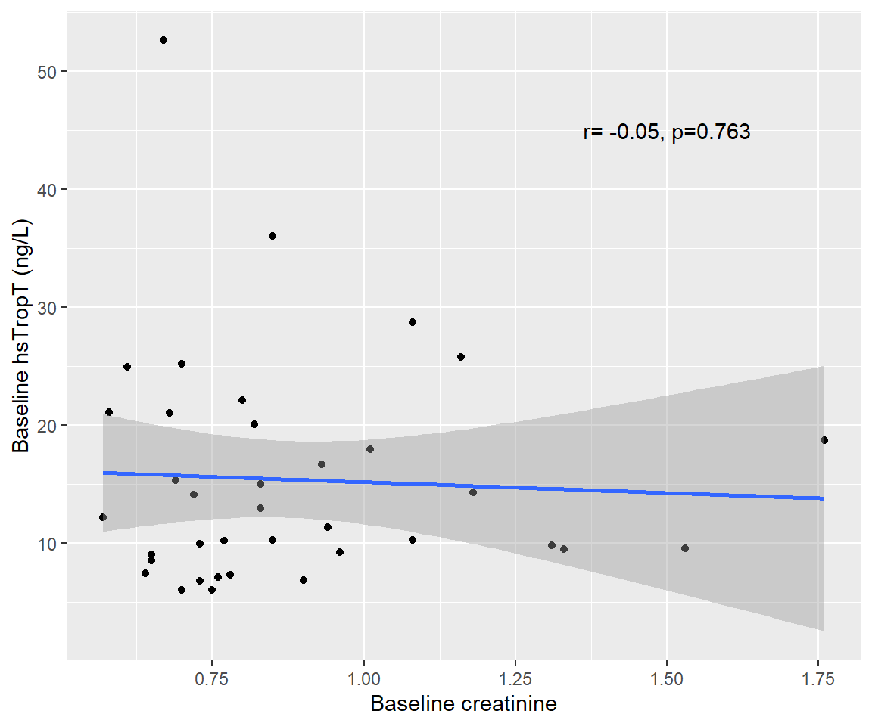

Figure S2: Visual depiction of levels of high sensitivity troponin T (hsTropT) and N-terminal pro-B natriuretic peptide (NTproBNP) among 40 patients who underwent chimeric antigen receptor (CAR) T cell therapy, with each circle representing a single patient at a particular time point. (A and B) Levels of hsTropT and NTproBNP at baseline, day 1, day 7, and day 21. (C and D) Levels of hsTropT and NTproBNP stratified by whether patients experienced grade 2 cytokine release syndrome (n=17/40; teal colored) or not (n=23/40; salmon colored) (E) Levels of hsTropT stratified by whether it was abnormal (>14 ng/L) at baseline (n=17/40; teal-colored) or not (n=23/40; salmon-colored). (F) Levels of NTproBNP stratified by whether it was abnormal (>125 pg/mL) at baseline (n=26/40; teal-colored) or not (n=14/40; salmon-colored).

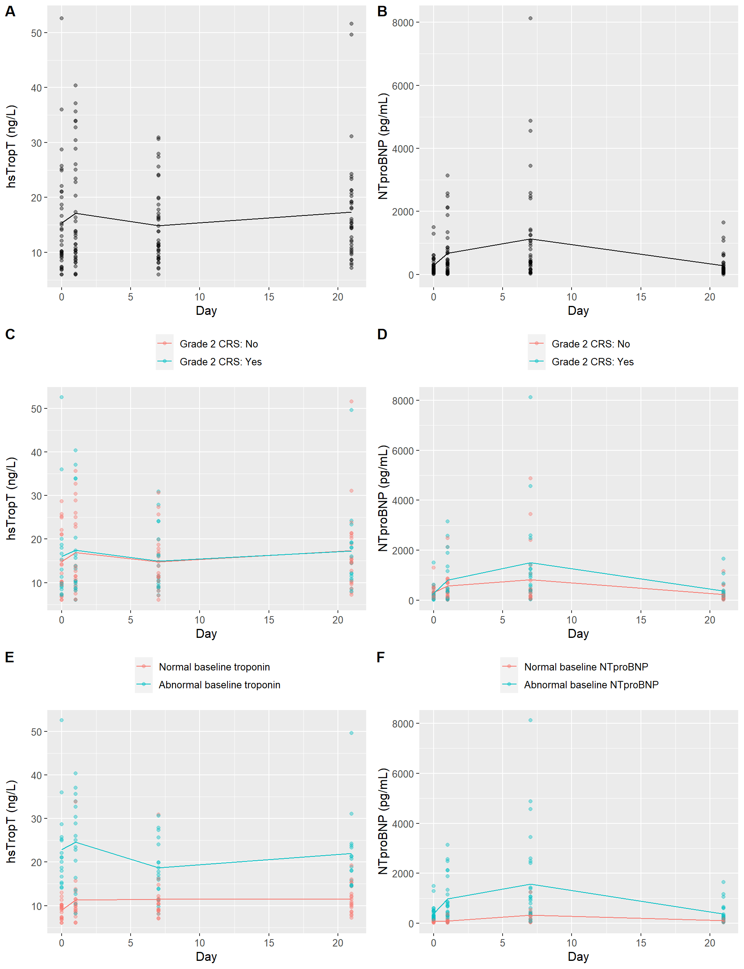

Figure S3: Visual depiction of levels of high sensitivity troponin T (hsTropT) and N-terminal pro-B natriuretic peptide (NTproBNP) among 40 patients who underwent chimeric antigen receptor (CAR) T cell therapy. Swimmer plots depict the progression of the laboratory values of individual patients in solid circles with connecting lines. (A and B) Levels of hsTropT and NTproBNP at baseline, day 1, day 7, and day 21. (C and D) Levels of hsTropT and NTproBNP stratified by whether patients experienced grade 2 cytokine release syndrome (n=17/40; teal colored) or not (n=23/40; salmon colored) (E) Levels of hsTropT stratified by whether it was abnormal (>14 ng/L) at baseline (n=17/40; teal-colored) or not (n=23/40; salmon-colored). (F) Levels of NTproBNP stratified by whether it was abnormal (>125 pg/mL) at baseline (n=26/40; teal-colored) or not (n=14/40; salmon-colored).
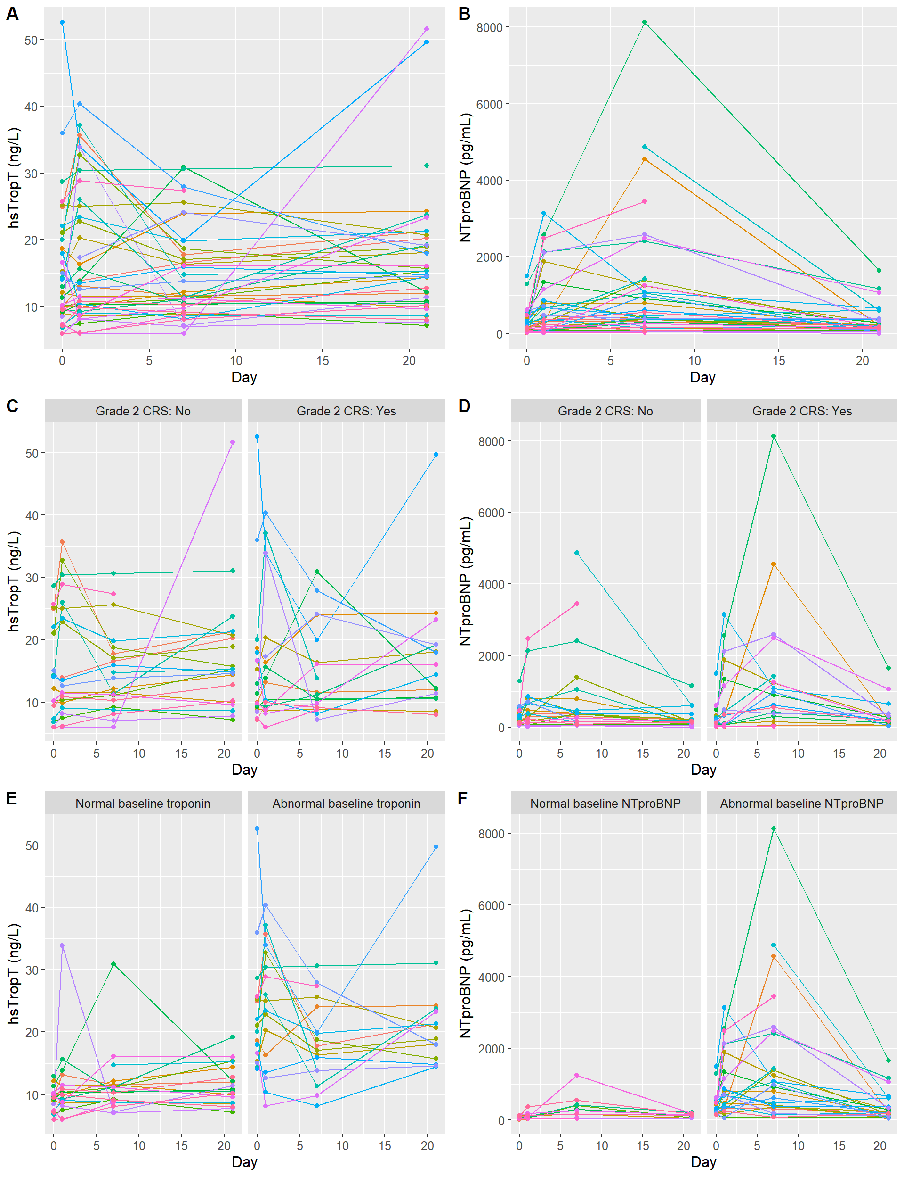

Figure S4: Visual depiction of levels of high sensitivity troponin T (hsTropT; left pane) and N-terminal pro-B natriuretic peptide (NTproBNP; right pane) among 40 patients who underwent chimeric antigen receptor (CAR) T cell therapy, at baseline, day 1, day 7, and day 21, stratified by whether patients had baseline cardiac comorbidities (n=23/40; teal colored) or not (n=17/40; salmon colored). Boxplots depict the 25th, 50th, and 75th percentile of each distribution with horizontal lines, whiskers extend 1.5 times the interquartile range above the third quartile and below the 1st quartile, and solid dots depict outliers. There was no interaction between the presence of cardiac comorbidities and hsTropT (F_{(3,93)}=0.91, p=0.44). There was no interaction between the presence of cardiac comorbidities and NTproBNP (F_{(3,93)}=0.98, p=0.41).
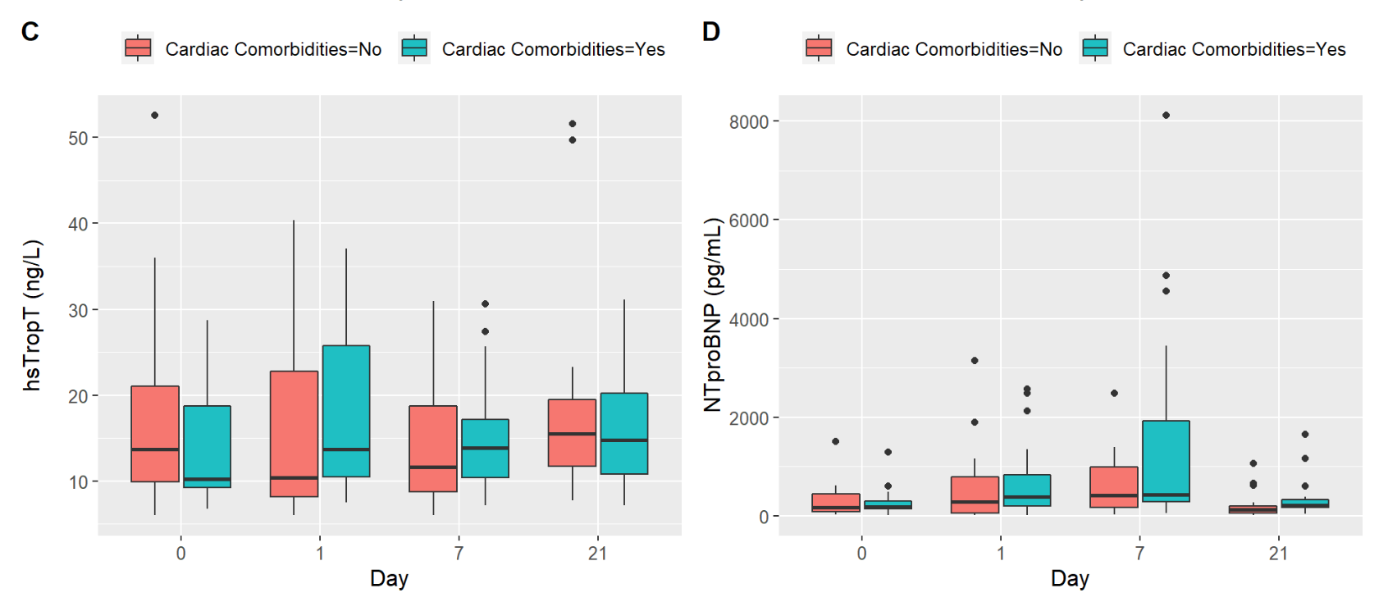

Figure S5: Visual depiction of levels of high sensitivity troponin T (hsTropT; left pane) and N-terminal pro-B natriuretic peptide (NTproBNP; right pane) among 40 patients who underwent chimeric antigen receptor (CAR) T cell therapy, at baseline, day 1, day 7, and day 21, stratified by whether patients experienced immune effector cell-associated neurotoxicity syndrome (ICANS) (n=19/40; teal colored) or not (n=21/40; salmon colored). Boxplots depict the 25th, 50th, and 75th percentile of each distribution with horizontal lines, whiskers extend 1.5 times the interquartile range above the third quartile and below the 1st quartile, and solid dots depict outliers. There was a significant interaction between presence of ICANS and timepoint in the levels of hsTropT (F_{(3,93)}=3.40, p=0.02). This is a result of hsTropT levels being higher in patients who developed ICANS compared to patients who did not develop ICANS, at all time points, but to a lesser degree at the day 7 timepoint. There was no interaction between the presence of ICANS and NTproBNP (F_{(3,93)}=2.29, p=0.08).

